**QR Sound box**

*This compact device generates instant audio confirmation of the payment done through any wallet or UPI application*

# 

**QR Sound Box**

**A device for your growing business**

# KEY FEATURES

* Quick and seamless installation.
* Instant audio payment confirmation.
* Long life rechargeable battery.
* No Wi-Fi required, it connects through SIM.
* Multiple language option.
* Easy to operate.
* Faster confirmation.
* Volume control keys with audio feedback.
* Replay button to listen last transactions.
* Single RGB LED to indicate power on and charging indication.
* Supports micro SIM card.
* Micro USB to recharge the device.

## How is QR Sound Box Different?

* **Fire and Remember**: Unlike Fire and Forget, the notifications played via QR Sound Box are recorded and can be accessed through our dedicated dashboard.
* **Analytics Dashboard**: QR Sound Box Dashboard provides detailed information about the sound box. One can access the battery level, network status, activity status, value and volume of transactions done etc. of each and every Sound box through the dashboard.
* **Indian Language Support**: QR Sound Box supports communication in local Indian languages ensuring that the device serves to a larger set of merchants.
* **Custom Notifications**: QR Sound Box can send custom notifications to the merchants. This can be bi-directional in nature. For example: If a merchant receives an offer regarding working capital loan and wishes to avail it, he/she can show interest by simply clicking any of the buttons available on the Sound box. The interest will get registered and will be passed on as a hot lead.

## SPECIFICATION

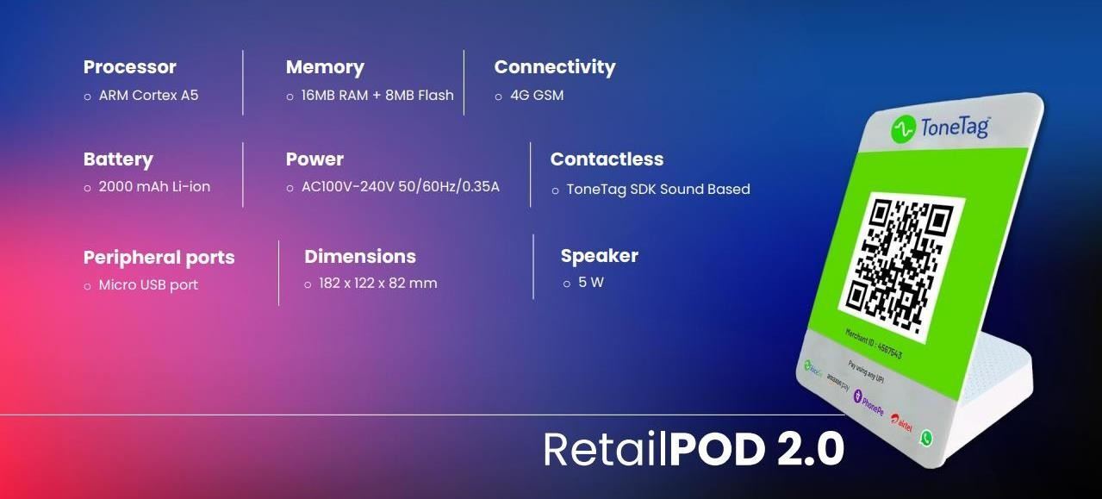

3

## ANALYTICS DASHBOARD



4

## ANALYTICS DASHBOARD

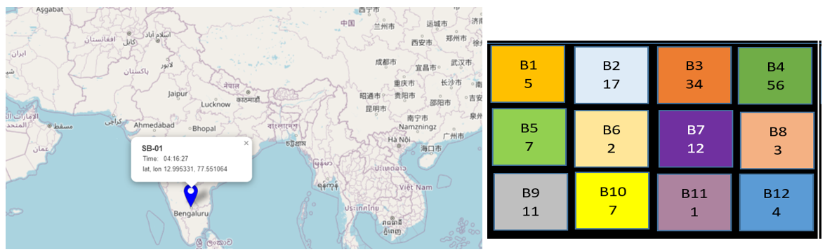

5